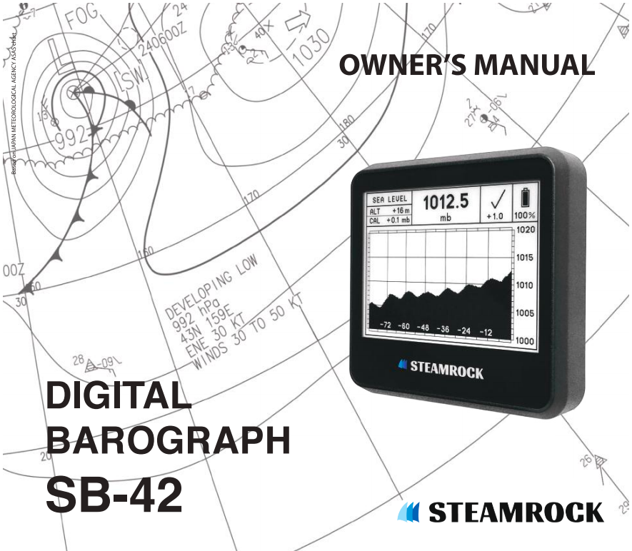

TABLE OF CONTENTS

FUNCTIONAL DESCRIPTION ………………….… 2
DISPLAY …………………………………………….. 2
WARNING MESSAGES ……………..……………...6
PUSHBUTTONS …………………………………….7
SETTING THE CALIBRATION …………….………7
SETTING THE ALTITUDE ……………………..… 8
RESETTING ………………………………………….9
TESTING …………………….…………………..….9
BATTERIES ……………………………………….…9
CAUTION ………………………………………..…. 10
LIMITED WARRANTY ………………………..…… 11
MOUNTING INSTRUCTIONS ……………………. 11
PACKAGE CONTENTS ………………………..…. 12
SPECIFICATIONS ..………….…………………… 12

1
FUNCTIONAL DESCRIPTION

The Steamrock SB-42 digital barograph detects and records changes in atmospheric pressure. It displays current atmospheric pressure, a graph showing changes in that pressure over 84 hours, and a World Meteorological Organization (WMO) symbol depicting changes over three hours. Beneath that symbol is a numeric value representing net value changes over the three hours.

Atmospheric pressure is measured every 30 minutes and is stored in a built-in memory. Results are shown on a high contrast sun readable e-paper display. Steamrock SB-42 is a standalone device that does not require software updates, internet connection, or an external power supply. It operates on three AAA batteries up to one year, with remaining charge displayed using a battery icon and percent remaining number.

Although this barograph is not a tool for extremely precise lab measurement, it is perfectly suitable for keeping track of atmospheric pressure tendencies. Thus, it can be used as an aid to navigation and an instrument for weather observation.

DISPLAY

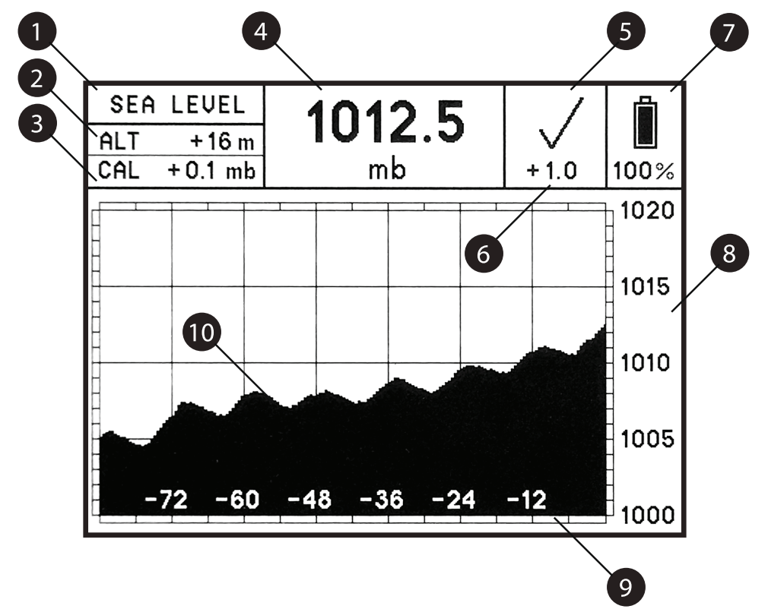

2

1) Pressure display mode

There are two atmospheric pressure display modes:

SEA LEVEL

In this mode, the device will calculate and display actual atmospheric pressure reduced to sea level atmospheric pressure after the user adjusts the device for current altitude above or below sea level.

STATION

In this mode, the device will display the actual atmospheric pressure at its location and elevation when altitude is set to zero.

2) Altitude

Altitude above or below sea level is displayed in meters.
Refer to SETTING THE ALTITUDE section for details.

3) Calibration value

The amount that the sensor has been corrected is displayed.
Refer to SETTING THE CALIBRATION section for details.

4) Current atmospheric pressure

Current atmospheric pressure is read every 30 minutes. The 30-minute period starts once the batteries have been installed, when the device has been reset, or any time a pushbutton is briefly pressed.

5) Three-hour pressure tendency symbol

A WMO symbol is used to represent the characteristics of atmospheric pressure tendency during the three hours preceding the time of current pressure reading, as described in the WMO manual:

3
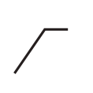
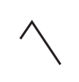
Code 0 Increasing, then decreasing;
atmospheric pressure the same as
or higher than three hours ago.

Code 1 Increasing, then steady; or increasing,
then increasing more slowly;
atmospheric pressure now higher than
three hours ago.

Code 2 Increasing (steadily or unsteadily);
atmospheric pressure now
higher than three hours ago.

Code 3 Decreasing or steady, then increasing;
or increasing, then increasing more
rapidly; atmospheric pressure now
higher than three hours ago.

Code 4 Steady; atmospheric pressure the
same as three hours ago.

Code 5 Decreasing, then increasing;
atmospheric pressure the same
as or lower than three hours ago.

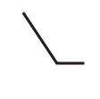
Code 6 Decreasing, then steady;
or decreasing, then decreasing more
slowly; atmospheric pressure now
lower than three hours ago.

Code 7 Decreasing (steadily or unsteadily);
atmospheric pressure now
lower than three hours ago.

Code 8 Steady or increasing, then decreasing;
or decreasing, then decreasing more
rapidly; atmospheric pressure now
lower than three hours ago.

4

6) Three-hour pressure tendency

The three-hour pressure tendency number represents the difference in millibars between the atmospheric pressure now and three hours ago. A positive number indicates that the pressure is now higher than three hours ago; a negative number indicates that it is now lower. If, for any reason, this number exceeds ± 99 mb, the symbol “---“ will replace the numbers.

7) Battery state

A battery icon and a percentage value provide the information on level of battery charge.
Refer to the BATTERIES section for details.

8) Pressure scale

The device has four pressure scale ranges. The scale shifts automatically to fit the graph to the screen, depending on the difference between maximal and minimal pressure displayed.

The scale range is divided into 20 units, whose values differ depending on maximal and minimal pressure displayed. The range the device uses most of the time is 20 mb (e.g., 1000 ~ 1020 mb or 1005 ~ 1025 mb) divided into 1mb units.

If the pressure change during the past 84 hours is more than 10 and less than 20 mb, which may happen during a significant weather event or if device is relocated to different altitude, the range will be 40 mb (e.g., 990~1030 mb) divided into 2 mb units.

The other two rarely used scale ranges are a 100 mb range divided into 5 mb units and a 200 mb range divided into 10 mb units. These two scales would be automatically chosen if the pressure change during past 84 hours were more than 20 and less than 50 mb or more than 50 and less than 100 mb, respectively. For example, this could happen when the device is transported over mountains with the batteries installed. In this case, the graph will accommodate a big change in pressure by reducing its vertical range, making differences slightly more difficult to distinguish. The device will automatically adjust the graph over the next 84 hours. If you do not want to wait for it to adjust the graph automatically, you can manually reset the device. Refer to the RESETTING section for details.

Note: If the difference between the maximal and minimal pressure exceeds 100 mb for any reason, the device will reset itself automatically. The screen will be updated showing the current pressure and a flattened graph returned to the 20 mb scale. When the device is reset, all pressure history records will be erased, but altitude and calibration settings will remain the same.

5

9) Time scale

The numbers and their corresponding vertical lines represent the number of hours that have passed since the most recent pressure reading.

10) Graph

The graph depicts the history of atmospheric pressures measured over the past 84 hours.

WARNING MESSAGES

The device might show one of two warning messages:

“Outside operating limits”

If the measured pressure is higher or lower than stated in SPECIFICATIONS section or if the sensor malfunctions, the display will show the warning message “OUTSIDE OPERATING LIMITS” on a blank screen. No measurements will be recorded while this message is displayed, though the device will continue monitoring the pressure every 30 minutes. Once the pressure returns to a range within the designated limits again, the barograph will automatically resume normal operation.

“Replace batteries”

When the charge of the batteries falls below operating limits, the display will show the warning message “REPLACE BATTERIES” on a blank screen. No measurements will be taken while this message is displayed. It is strongly recommended that you replace or remove the batteries when this message appears. Refer to BATTERIES section of this manual for more details.

6

PUSHBUTTONS

There are three pushbuttons on the rear side of the device to the right of the batteries.

These pushbuttons are “+”, “-“ and “R”. Under normal operating conditions there is no need to use the pushbuttons, because the scale and graph will be automatically selected. These pushbuttons will, however, need to be used for initial setup, calibration, reset, or when the device has been relocated to a different altitude.

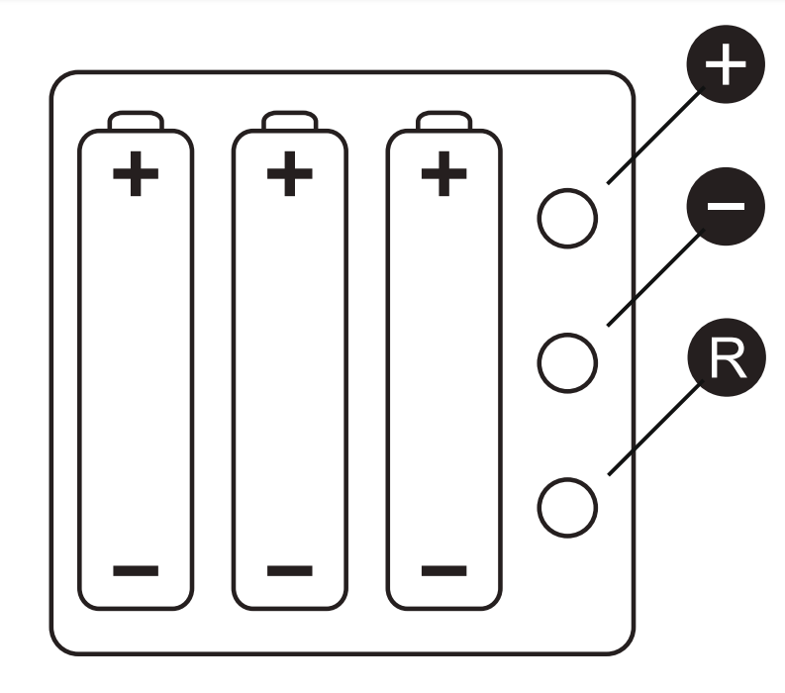

SETTING THE CALIBRATION

Your barograph is shipped with the calibration (correction) setting already pre-set. You may want to introduce your own calibration, for example, when you see it is slightly differing from a local trusted source or if you need to adjust for normal sensor drift.

If you believe that this device’s pressure reading is lower than actual local pressure, you can increase the calibration (CAL) number by pressing and holding the "R" pushbutton until you hear a short beep. While you continue holding the "R" pushbutton down, press and hold “+” pushbutton until you hear a short beep, indicating the addition of 0.1mb. The “+” pushbutton will keep adding 0.1mb to the barograph’s reading with each beep as long as you hold it down.

7

If you believe that the device’s pressure reading is higher than actual local pressure, you can reduce the CAL number by pressing and holding the "R" pushbutton until you hear the short beep. While you continue holding the "R" pushbutton down, press and hold “-” pushbutton until you hear a short beep, indicating the subtraction of 0.1mb. The “-” pushbutton will keep subtracting 0.1mb from barograph’s reading with each beep as long as you hold it down.

Note that the CAL number will not be updated on the screen until the pushbuttons are released. Therefore, you need to keep counting the beeps until the desired number is reached. Then, release the pushbuttons.

After releasing the pushbuttons, check the CAL number on the screen. If the CAL number is not the number you intended, you can readjust it using the same procedures as described above.
The CAL number can be adjusted as much as ±10 mb.

SETTING THE ALTITUDE

When you move the device to a new location, you may need to adjust its altitude setting. To increase or decrease the altitude (ALT) number, simply press and hold the “+” or “-“ pushbutton. After one second of pressing, you will hear a short beep, indicating a 1m increase or decrease in altitude setting, depending on which button you push. The pushbutton will keep adding or subtracting 1m to or from the ALT setting with each beep as long as you hold it down.

Note that the ALT setting will not be updated on the screen until the pushbutton is released. Therefore, you need to keep counting the beeps until the desired altitude setting is reached. Then, release the pushbutton.

After releasing the pushbutton, check the ALT setting on the screen. If it is not the altitude number you intended, you can readjust it using the same procedure as described above. The altitude can be set at any whole number between -200m and +1000m.

To add or subtract tens or hundreds of meters, you will need to follow these simple instructions:

To add 10m per step, press and hold the “+” pushbutton indicating you want to add until you hear a short beep. While you continue holding the “+” button down, press “-“ pushbutton to get the device to add in tens of meters. Each double beep you hear will indicate that 10m has been added. To add 100m per step, follow the same procedure except instead the pressing the “-“ for tens, you press the “R” for hundreds. Each triple beep you hear will indicate that 100m has been added.

8
To subtract 10m per step, press and hold the “-” pushbutton indicating you want to subtract until you hear a short beep. While you continue holding the “-” button down, press the “+“ pushbutton to get the device to subtract in tens of meters. Each double beep you hear will indicate that 10m has been subtracted. To subtract 100m per step, follow the same procedure except instead the pressing the “+“ for tens, you press the “R” for hundreds. Each triple beep you hear will indicate that 100m has been subtracted.

RESETTING

1. The device can be reset if you want to clear the pressure history records and manually set the 20 mb scale, for example, when you have relocated the device to very different altitude and do not want to wait for the device to automatically adjust its scale range over time.

To reset the device, press and hold the “R” pushbutton. You will hear a short beep in about 1 second. Continue holding it for about 8 seconds until you hear 3 short beeps. Release the "R" pushbutton immediately. The screen will be updated, showing the current pressure and a flattened graph set at a 20mb scale. All pressure history records will be erased, but altitude and calibration settings will remain the same.

TESTING

Electronic paper displays do not need power to retain their images. Therefore, this device will continue displaying the last image on the screen even in the unlikely event of a malfunction or loss of power.
To test the device’s functionality, briefly press any pushbutton. If functional, the screen will be updated and the most recent pressure readings will be displayed.

BATTERIES

Use high quality batteries only. Panasonic® EVOLTA AAA alkaline batteries are recommended for this device. If you decide to use another brand, you may want to google that brand for "leakage" prior to choosing.

Zinc carbon batteries can be used, but they typically have less capacity.

NiMH rechargeable batteries can be used, but the battery charge state (displayed on the screen) will not be correct and the operating time will be shorter.

Lithium primary batteries were not tested with device. Use them at your own risk.

9
Replace all batteries at the same time. Do not mix old and new batteries and do not mix different types of batteries or batteries produced by different manufacturers, since this may lead to leaks that can damage the device.

When battery charge falls below operating limits, you will see warning message "REPLACE BATTERIES" on a blank screen. The device will also produce beep to the tone of the Morse code letter “B” ( _ ... ) once.

When you see the "REPLACE BATTERIES" warning, replace the old batteries as soon as possible. At least, remove them, since leakage of discharged batteries can cause permanent damage to the device.

When installing the batteries, be sure to observe the polarity marked in the battery holders. In this device, all positive terminals are up.

IMPORTANT:
Reverse polarity will damage the device permanently.

When new batteries are inserted, the device will re-start automatically. It will measure current atmospheric pressure and display it on the screen along with the data previously stored in the memory. The every 30-minute measurement will start at this time.

No matter if the batteries are low or removed, the device will keep previous records and settings in its internal memory. There may be a sudden discordant “step” on the graph if you replace the batteries a while after you have noticed the warning message "REPLACE BATTERIES" due to changes in atmospheric pressure that have occurred during down time.

Before leaving the device unattended for a prolonged period of time, check the battery charge. If the battery charge is low, you may want to replace or remove the batteries to keep them from falling below operating limits while unattended and prevent battery leakage.

CAUTION

This device was designed for indoor use only. Although the face of the device is generally splash proof, it should not be exposed to rain or liquids from other sources such as cleaning.

Do not clean with chemicals, expose it to direct sunlight or operate it below 0 °C (32 °F).

If the device’s batteries have been replaced, the device has been reset, or the CAL/ALT has been adjusted, it will take 3 hours to get a fully accurate 3-hour tendency symbol and 3-hour pressure tendency.

In no case should this device be used as the sole basis for weather prediction or navigation decisions. The user assumes sole responsibility legal or otherwise for these decisions.

10
LIMITED WARRANTY

If within one year from the date of original purchase, this device is found to be defective, in material or workmanship, it will be replaced or repaired at the discretion of the manufacturer.
This warranty excludes water or chemical damage, battery leakage, use of wrong types of batteries, installing the batteries in reverse polarity, physical damage, and use of device outside operating limits.

Please refer to “Limited warranty” section at steamrock.com for full details.

MOUNTING INSTRUCTIONS

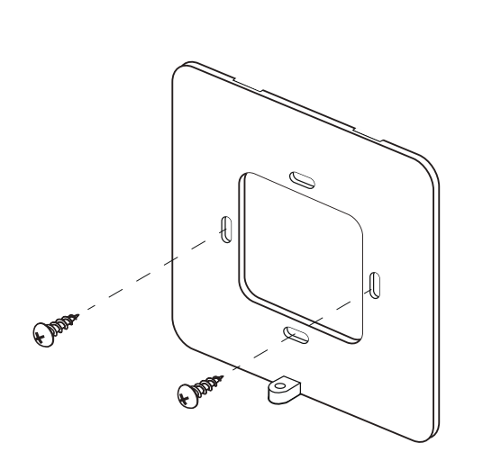

- Remove the mounting plate from the back of the device using the Phillips mini screwdriver provided.

- Using the two stainless screws provided and your own screwdriver, attach the mounting plate to the bulkhead or wall with its top indented slots facing the wall and bottom bracket with threaded bolt hole facing outwards.

11
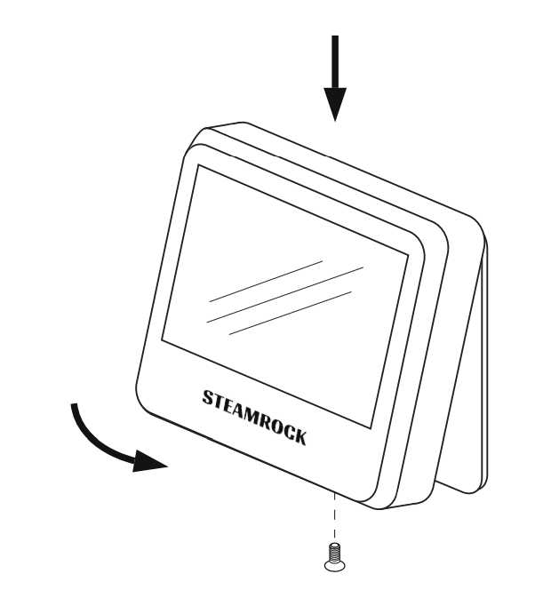
- After inserting the batteries, enter the calibration and altitude settings (if necessary) and mount the device on the bulkhead or wall by inserting the small flat hooks on the top inner side of the casing into the mounting plate’s indented slots. Carefully push it in place.

- Screw in the bolt at the bottom of the casing using the Phillips mini screwdriver provided.

PACKAGE CONTENTS

- Steamrock SB-42 digital barograph 1
- Owner’s manual 1
- AAA batteries 3
- Phillips mini screwdriver 1
- Stainless screws 2

SPECIFICATIONS

Dimensions 105 x 105 x 25 mm (4.14” x 4.14” x 1”)
Weight 185g (without batteries)
Power 3 x AAA (4.5V)
Display 4.2” b/w e-paper (85 x 64 mm)
Absolute accuracy 1 mb at 0 ~ 50 °C (32 ~ 122 °F)
Long term drift < 1 mb / year
30-min timing accuracy < 1%.

Operating limits:

Pressure range 500 mb ~ 1100 mb
Temperature 0 ~ 50 °C (32 ~ 122 °F)

12 © Steamrock Inc.

